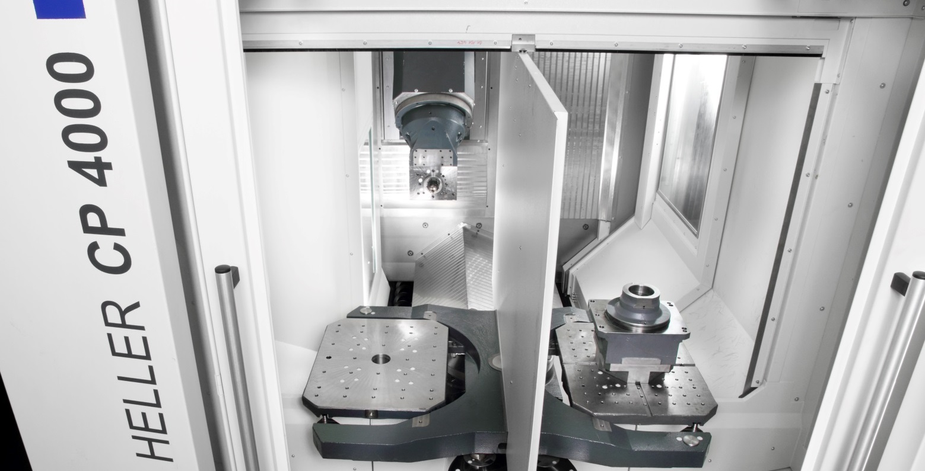
July 2014

HELLER at AMB 2014 in Stuttgart:
Persuasive productivity

Press relations
Gebr. Heller Maschinenfabrik GmbH

Marketing
Marcus Kurringer
Gebrüder-Heller-Straße 15
72622 Nürtingen
Germany
Phone: +49 7022 77-5683
Fax: +49 7022 77-165683
marcus.kurringer@heller.biz

HELLER at AMB 2014 in Stuttgart: Persuasive productivity
For decades, high cutting capacity and performance or absolute reliability, and thus top-level availability, have formed the DNA of HELLER machining centres. At AMB 2014, the company will again be setting new standards in terms of productivity with a coherent overall concept across the entire machine range. Machining centre model H 4500 embodies the entry into the HSK100 class, whilst machining centre model FP 4000 is synonymous with powerful machining in 5-axis applications. Combined turning and milling operations can be accomplished on mill/turning centre model CP 4000 or classic 4-axis machining centre model H 2000 equipped with out-facing head.

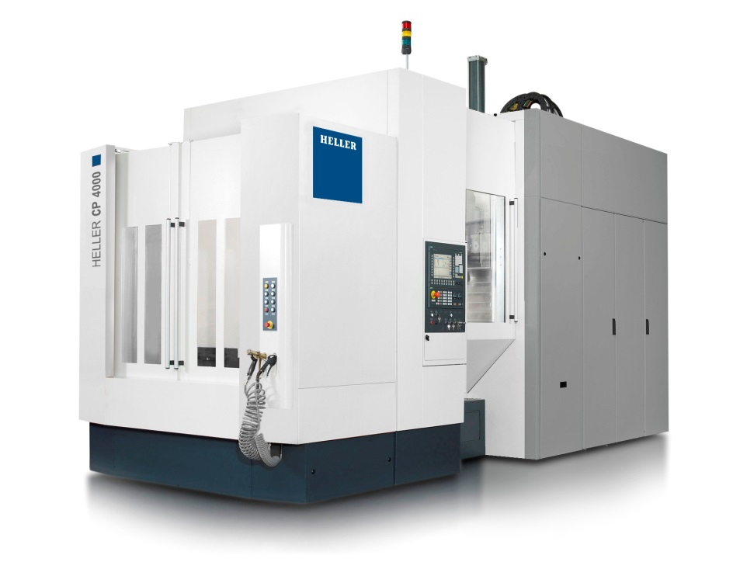
5-axis mill/turning centre model CP 4000:
Highly productive turning included
With the C series, HELLER is offering an almost unique performance package in this sector. However, the C series cannot be compared to conventional machining centres with integrated turning function anyway. The machine in focus at AMB 2014 will be 5-axis machining centre model CP 4000 equipped with PCU63 machining unit offering 242Nm torque and 44kW power. In addition to 5-axis machining with spindle speeds up to 24,000rpm, HELLER's approach to complete machining with model CP 4000 focuses on turning with a fifth axis provided by the tool. Horizontal and vertical turning of outer and inner contours can be accomplished without any problem using the C axis and the optional A and B axis. The rotary table with direct torque drive delivers speeds up to 1,000rpm and provides the necessary power when the workpiece rotates against the tool. The C series guarantees high economic efficiency when predominately cubic features are machined with an emphasis on high process dependability, automation and precision and rotation-symmetrical components with a length-to-diameter ratio of below one are required.

True greatness is in the detail
To achieve the high cutting performance, HELLER uses a specially developed and extremely stiff swivel head geometry. To increase torsional stiffness and form fit, the machine can be equipped with an additional spindle locking feature. With batch sizes decreasing and part diversity increasing, combined processing provides the necessary flexibility for meeting future demands. Highly productive cutting using economically efficient cutting data forms part of HELLER's DNA. To support this, HELLER uses Siemens Sinumerik 840 Dsl, enabling demanding mill/turning operations whilst providing highly precise control of speed and acceleration and variable adjustment to different requirements in terms of precision and surface finish.
HELLER is offering the C series in two machine variants (CP/pallet changer or CT/table loading). The work area of model CP 4000 with a work envelope of 800x800x1,045mm (X, Y, Z) is suited for pallets of 500x600mm and workpieces with a maximum height of 1,000mm. Another highlight of model CP 4000 is an in-house developed function for identifying imbalances on the workpiece or the rotary table. It enables centric clamping with high repeatability by identifying even the slightest imbalances on the workpiece using signals provided by the drive and without the need for additional sensors – a vital safety aspect. A sophisticated user interface supports the operator in correcting imbalances. Especially for turning tools, HELLER's standard tool measurement function using tactile sensors is useful.
With the C series, HELLER is also following the trend of hybrid technologies, meeting the permanent demand for machining of rotation-symmetrical components, mainly from the sector of power and drive engineering. These industries will benefit from the fact that this can now be achieved at high cutting capacity. These benefits also result from HELLER's inherent qualities.

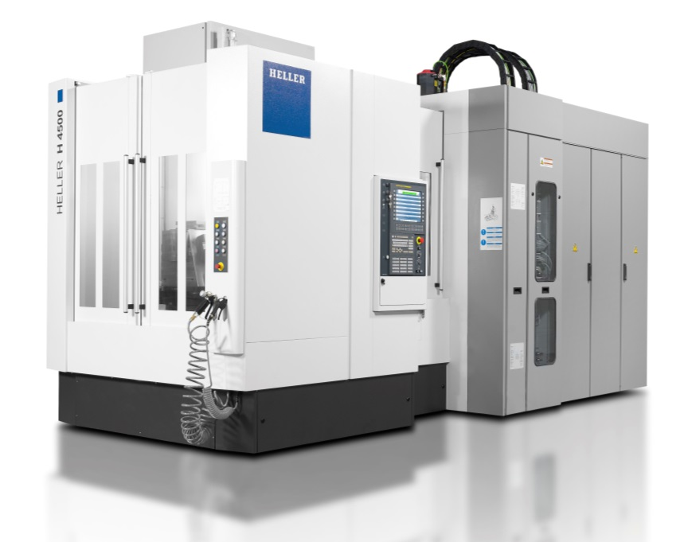
4-axis machining centre model H 4500:
Robust and quality-conscious with HSK 100
In a nutshell, 4-axis machining centre model H 4500 could be described as highly standardised and designed for robust processes. HELLER will be pushing the boundaries of this machine size at AMB 2014. The necessary stability required for achieving the high chip removal rate is based on the inherently rigid design of the machine bed, the twin drive in the Z axis, the dynamically stiff, short overall design of the spindle unit and the water-cooled spindle neck. Yet above all, the machining centre combines HELLER's inherent qualities making it the perfect choice for a wide range of applications. High performance and precision are guaranteed from light-metal machining through to heavy-duty cutting, with changing batch sizes and a variable range of parts and materials, with application of dry or MQL machining. To enable this, the machine provides comprehensive standard equipment such as the chain-type tool magazine with 50 storage places, tactile tool measurement and a work envelope of 800x800x800mm (X/Y/Z). However, model H 4500 is also versatile in terms of tool management. The B axis with a load capacity of 1400kg contributes to the broad spectrum of machining applications.

Unique performance parameters for a robust all-rounder
In the design of 4-axis machining centre model H 4500 HELLER combined all the advantages of horizontal machining. This also includes chip management. Free chip fall below the spindle and between the rotary table and the pallet changer, steep chip chutes in the work area and at the setting station as well as a 600mm wide scraping conveyor covering the complete Z-stroke are standard at HELLER. Model H 4500 presented at AMB will be equipped with the newly developed Power Speed Cutting spindle PSC100. The spindle offers 52kW power, 500Nm torque and a speed of 12,500rpm. These performance parameters show that HELLER was not focusing on rapid traverse and acceleration rates with model H 4500 but on realistic dynamic rates, making the H 4500 a robust all-rounder in the HSK-A 100 range.
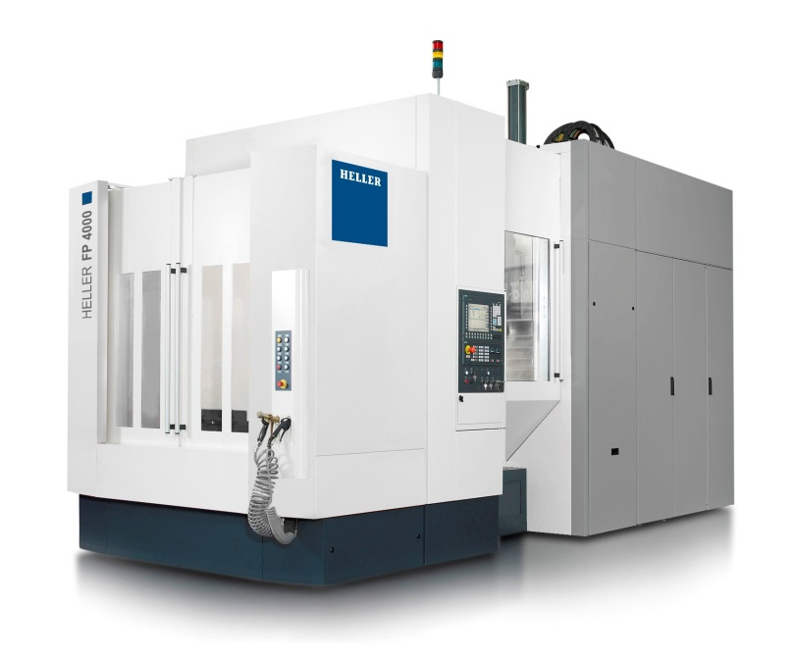
5-axis machining centre model FP 4000:
Combining productivity and precision
High productivity remains paramount to the machine tool manufactrer based in Nürtingen. The same is true for 5-axis technology. With the F series (particularly with model FP 4000 showcased at AMB 2014) HELLER is showing that 5-axis milling does not always mean dealing with filigree structures or a supposed loss in precision vs. horizontal machining. On the contrary, throughout the development special emphasis was placed on uncompromising productivity, process dependability and high workpiece loads. With possible workpiece loads of up to 1,400kg and a spacious work area (work envelop of 800mm in the X axis, 900mm in the Y axis and 1,045mm in the Z axis), model FP 4000 provides universality, flexibility and absolute precision at the highest level. The use of direct measuring systems with absolute encoders, high-resolution rotary encoders and YRT bearings with integrated measuring system is standard just as 5-axis kinematics provided by the tool in X, Y, C and/or A axis. Combined with two additional axes provided by the workpiece in Z and B, this results in precision and high dynamics (rapid traverse rates of 60m/min and acceleration rates of 6m/s²) for fast positioning.

Potential for process optimisation
The significant advantage provided by 5-axis machining enabling complete machining in a single setup can only be realised with a coherent overall concept. The power provided, for example, must be right and be available at any spatial angle. It means placing the emphasis in investment on productivity, cutting capacity and availability in order to achieve benefits in the mid- and long-term. With the features presented at AMB, such as the Speed Cutting Tilt SCT 63 fork head for high-speed machining, 40kW power, 16,000rpm speed range and 80Nm maximum torque, HELLER is setting the standards in these respects. In addition to providing high chip removal rates, the SCT also enables machining at negative angles below the centre axis. Beyond doubt, 5-axis machining holds great potential for process optimisation. When the milling cutter is tilted, for instance, using tools with a reduced throat depth becomes possible. As a result, machining times are shorter and the surface finish is improved due to the reduced susceptibility to vibration. Peripheral milling or face milling of sculptured surfaces provide further potential. Instead of highly dynamic milling at low feed rates, HELLER is offering machining at high feed rates with model FP 4000. An approach that has been paying off already for many users of the F series.

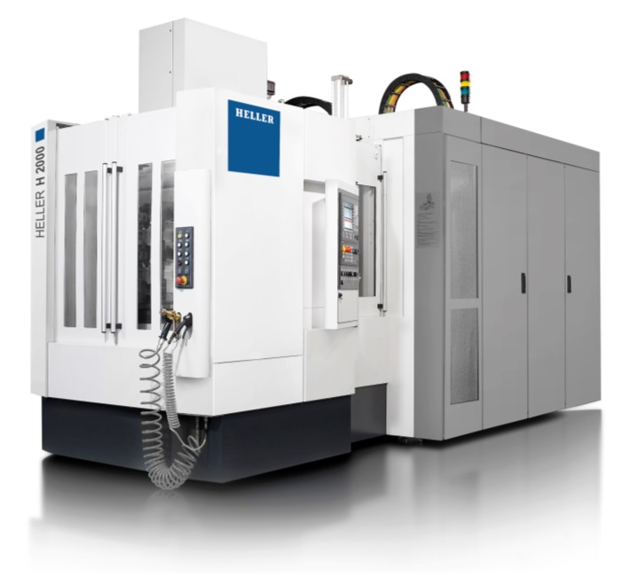
4-axis machining centre model H 2000:
On the winning track with combined processes
By now, the machining centres from the H series have become the best-selling machines from HELLER and it seems there is still plenty of potential. At AMB 2014, HELLER will be exhibiting 4-axis machining centre model H 2000 in co-operation with the Institute for Production Management, Technology and Machine Tools (PTW) of Darmstadt University of Technology to showcase how productivity, universality and economic efficiency can be brought together in combined processes. The focus will be on honing operations using the integrated out-facing head. Contrary to classic machining concepts, this approach combines milling and turning functions. The concept of the out-facing head is based on the integration of an additional axis in the tool for radial control of the cutting edge. HELLER also refers to this axis running through the centre of the spindle as adjusting shaft. As a result, the drive unit is fully automatically coupled to the out-facing head and the tool through the centre of the spindle.
With its cutting capacity, precision in all sizes and the discussions on energy efficiency, machining centre model H 2000 remains in the spotlight. This cutting performance HELLER achieves by means of a robust basic construction, a twin-drive in the Z-axis for symmetrical force application and free chip fall. Precision is guaranteed through reduced table deformation and internally arranged drives providing high accuracy. In terms of energy efficiency, HELLER moved into a new era long ago. On the H series, for instance, regenerative drive systems, servomotors enabling a more efficient use of the overall speed range or reduced-power valves as well as standby strategies have been state-of-the-art for years just as stand-by strategies or speed-regulated high-pressure pumps for coolant units.

Short profile HELLER Group
Founded in: 1894 in Nürtingen
Workforce 2013: 2,450
Turnover 2013: EUR 533m
Chairman of the Board: Berndt Heller
Managing Directors: Manfred Maier (COO of the HELLER Group)
Christian Pfleiderer (HELLER Services GmbH)
Klaus Winkler (CEO of the HELLER Gruppe)
Fields of business: Horizontal machining centres, 5-axis machining centres, mill/turning centres, flexible manufacturing systems, crankshaft and camshaft machines, CBC systems, services
Production locations: Germany (Nürtingen) United Kingdom (Redditch) USA (Troy/Michigan) Brazil (Sorocaba)
China (Changzhou)
Sales/Service locations: EUROPE:
Germany (Hattingen, Salem, Goslar, Saarbrücken, Kirchheim,
Nuremberg)
Italy (Verona) France (Paris) Spain (Barcelona, Santander)
Sweden (Värnamo)
Switzerland (Niederbüren)
Slovakia (Vráble)
Russia (Yekaterinburg)
NORTH/SOUTH AMERICA
Mexico (Querétaro) Brazil (Belo Horizonte, Gravataí, Joinville)
ASIA
China (Beijing, Changchun, Shanghai, Chongqing, Nanning)
India (Pune)
Thailand (Bangkok)
Singapore

